Putting rhetorical analysis into practice

Let’s experiment with some of the concepts we introduced in our Rhetorical Analysis tip sheet.
Below is an image of a composition by the New Orleans street artist Az. Let’s attempt to do some initial rhetorical thinking about his text.
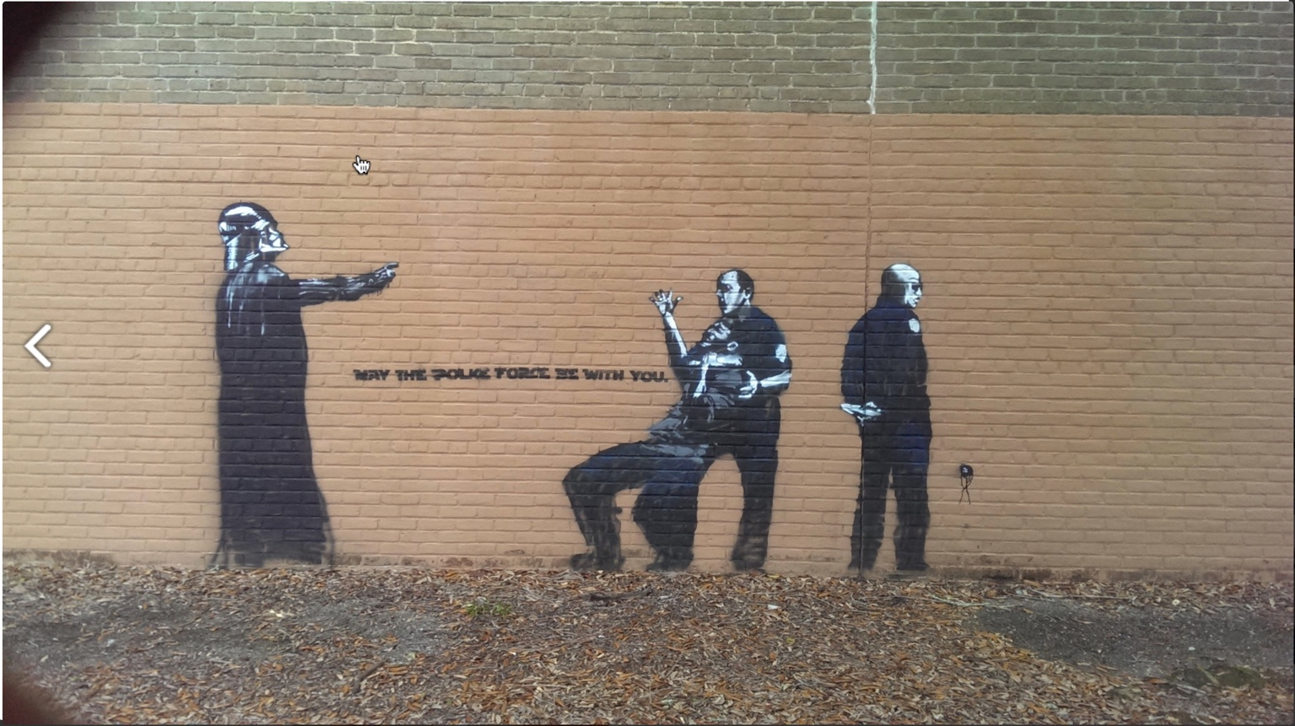
Figure 1: Az, "May the Police Force Be with You." Image courtesy of http://www.azwashere.com/walls/index.html

As an initial step, let’s see if we can get a sense of the rhetorical situation within which this composition was made. In order to do this, it will help to begin listing the specific details or elements about the composition. Such a list might include things like the following: identifies as street art, juxtaposes Darth Vader using his iconic choke move with police officer holding a black man in a choke hold, uses caption “may the police force be with you” …
Remember, when considering the rhetorical situation of a text, we can start with three primary elements: exigency, audience, and constraints.

What is the exigency for this composition?
If exigency is the problem or reality that motivates someone to compose a text, the exigency here is most likely the problem/reality of police violence or the use of force in black communities.

Who is the audience?
If audience is to whom this image is addressed, the answer may not be immediately evident. On the one hand, since we know this is a piece of street art, we might assume that the audience of this piece is the residents and pedestrians that live and move through this particular neighborhood. At least a few questions emerge here that might help us further define the audience: Does this composition appear in a neighborhood where the use of police force on people of color is not an issue or problem? Or, does this appear in a neighborhood in which the use of force by police on people of color is a problem? Or, is it more complex even than that?

What are the constraints?
Constraints might be the most complex and slippery element of the rhetorical situation. One constraint this composition has is the composer’s choice to use street art as their means of rhetorical action. A painting on a wall is potentially limited in only being able to be seen by those who come into contact with it in that neighborhood. Also, given that street art is often considered illegal, there’s a chance that the composition will be covered or otherwise removed before its audience has a chance to interact with it. Additionally, constraints also include things like people’s attitudes and beliefs. That this composition takes up the issue of police violence is going to constrain its ability to appeal or persuade or communicate with people dependent on their own attitudes and beliefs about the police or black men. It also juxtaposes this issue with a beloved piece of American popular culture (Star Wars), which will also constrain how its message is received with particular people or groups. Can you identify more constraints in this situation?

What about the ancient rhetorical appeals – ethos, pathos, and logos?
Like the concept of the rhetorical situation, we can turn to the appeals to start getting a better sense of how the composition works rhetorically and how it was rhetorically designed by a composer.
If pathos is the ability to elicit an emotional reaction from the audience, then it seems that this might be the most obvious appeal being used. People love Star Wars. People are also often intensely and emotionally conflicted about issues involving policing and race. What sort of emotional reaction do you think the composition tries to elicit in relationship to black men and the police force? About the police?
If ethos is the use of credibility and character to make a case and gain approval, how, if at all, might this composition be using ethos? One possibility might be the use of Star Wars iconography like Darth Vader. Again, people love Star Wars, and people tend to like it because it offers a sophisticated parable of the struggle between good and evil, light and dark. Might the composer juxtaposing Darth Vader, an ultimately complex and conflicted character, with the police be a means for establishing credibility with a particular audience, perhaps one that also sees policing as a complex and conflicted endeavor? Additionally, the visual style of Az’s composition evokes, and even mimics, the style of the very famous and well-respected street artist Banksy. The choice to adhere closely to Banksy’s visual style could be read as an attempt to use the credibility and character of a well regraded street artist to validate this work.
Logos, or using sound reasoning to convince an audience, probably seems the least evident appeal in this composition. We often associate logos with the use of statistics and other forms of what we tend to call hard evidence. Sound reasoning, however, isn’t always a statistical endeavor. Here again, the use of Darth Vader and the Star Wars’ conception of “force” proves interesting. In the Star Wars films the “force” – the energy and power flowing through all things – has a dualistic logic. The “force” in Star Wars is neither good nor evil but has the potential to be used to both ends – it’s complex. Might the composer’s juxtaposition of the Star Wars’ “force” with “police force” be an example of using sound reasoning, or logic? Of appealing to the audience’s sense of complexity, or duality, in regards to the issue of police violence? What do you think? Additionally, it might be an interesting thought experiment to ask: what if the composer had used a statistic about police force and people of color in the painting? Or, what if the black man in the choke hold, or the police officers, were literal representations of actual people involved in an incident of police violence?

Rhetoric is complex
It’s important to remember that rhetoric is complex. That’s one reason why people find it interesting to study and invite students to think rhetorically about texts. This means that what we’ve sketched out above remains open to interpretation and argument, and there is, of course, way more that could be said about Az’s painting.
As a means of continuing to hone and sharpen your rhetorical thinking skills we encourage you to locate compositions that you find compelling and consider such things as the rhetorical situation and the use of rhetorical appeals.

